**COMMAND LINE**

* $ touch abc.txt //creates a new empty file
* $ cat abt.txt //displays the content of file
* $ mkdir dir_name //to create new directory.
* $cd dir_name // change directory to another already defined dir.
* ‘/’ specifies root dir.
* $pwd // present working dir.
* $ls //list of files & dir s in pwd
* $cd .. // cd to parent dir
* $cd // cd to home dir automatically.
* $mv file dest_dir //move file to dest_dir
* $mv dir_name dest_dir //we can also move, dir_name to dest_dir.
* $cp file_to_copy new_file_name // copy a file
* $cp -r directory_to_copy new_directory_name //copy dir using “Recursive copy”.
* $rm file_name //to remove file
* $rm -r dir_name //to remove dir

- $mv old_filename new_filename // ‘mv’ can be used to rename a file or dir.

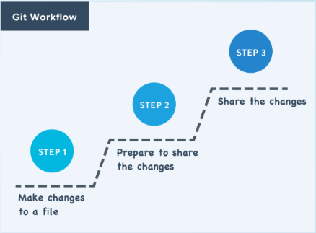

**GIT**

* $git init //initialise an empty repo.
* $git add filename //to select a file.
* Sharing Process

-Git uses something called a **remote** (or remote repository) to store shared files.

-Developers share files by uploading to and downloading from remotes.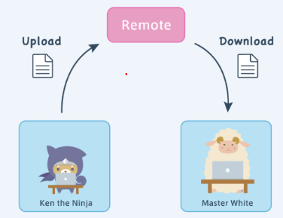

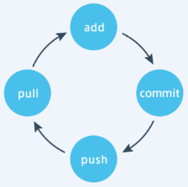

* $git remote add remote_name URL //to register a remote.
* $git push remote_name master //uploading to remote from local : **PUSH**
* $git pull remote_name master //downloading from remote to working dir. : **PULL**
* $git status //to check status; list the files that u have modified but still

// need to be ‘add’ or ‘commit’.

* $git diff //to recognize content changes.
* $git status
  + Green - added to staged area but yet to be committed.
  + Red - neither added nor committed.
* $git log //to view all the commits , with ‘commit messages’.
* $git log -p //to view all the commits and their changes.